IMPACTS OF HUNGER, FOOD INSECURITY, LANDLESSNESS ON WOMEN AND CHILDREN IN COPPERBELT PROVINCE-MPONGWE, LUANSHYA AND LUFWANYAMA DISTRICTS OF ZAMBIA

REPORT

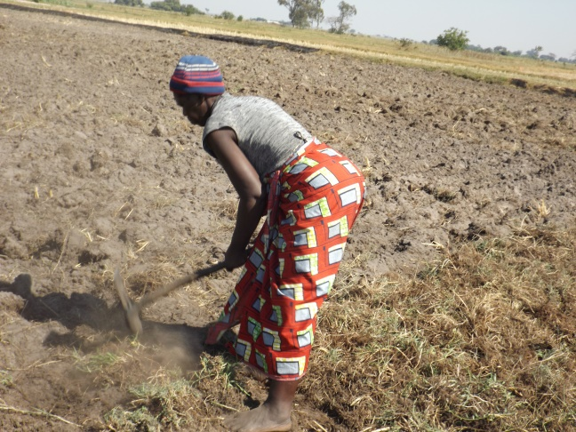
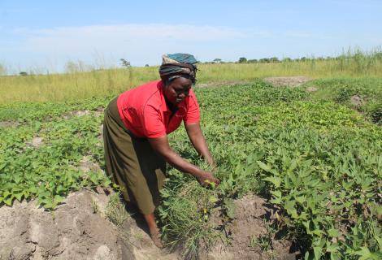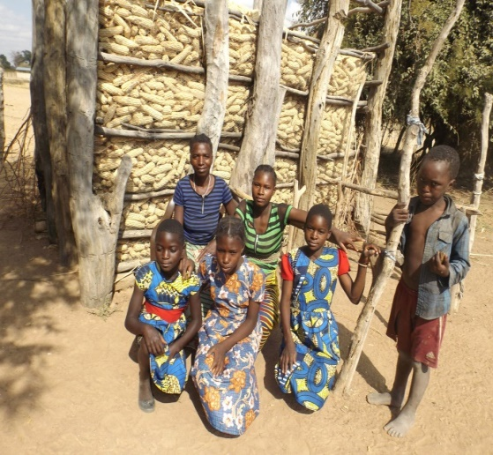
By
HENRY W.SINGILI
NATIONAL COORDINATOR
ESAFF ZAMBIA
CELL: +260 979818412
Email: esaffzambia@yahoo.co.uk

FUNDED BY

CPDE Rural Constituency
Eastern and Southern Africa Small scale Farmers’ Forum Zambia

Acknowledgement
We are grateful to CPDE Rural Constituency who awarded us this study for the financial and technical support during this exercise. We are also indebted to Members of the ESAFF Zambia Board who were instrumental in the design and writing of this proposal and coordinating the process of data collection. We are equally grateful to the key informants including Traditional Leaders, District Staff at the Ministries of Agriculture and Community Development for key information on policies and measures taken on COVID 19. Not forgetting to thank the small scale farmers and their families in the communities we visited in Mpongwe, Luanshya and Lufwanyama.

Table of Content
Content Page No
Acknowledgement 1
Table of Content 2
Abbreviations 3
Chapter One: Background and Introduction 4
Statement of the Problem 4
Objectives 5
Study Area 6
Significance of the Assessment 6
Chapter Two: Literature Review 8
Chapter Three: Research Methodology 10
Study Design 10
Sampling 10
Data Analysis 11
Ethics 11
Study Limitation 12
Chapter Four: Study Findings and Discussion 13
Chapter Five: Conclusion and Recommendation 16
References 19

Abbreviations
CEDAW Convention on the Elimination of All forms of Discrimination Against Women
COVID 19 Corona Viruses 19
DCD District Community Development
DCDO District Community Development Office
FAO Food Agriculture Organization
FGD Focused group discussion
FISP Farmer Input Support Programme
FRA Food Reserve Agency
GDP Gross Domestic Product
HMS House Monitoring Survey
JCTR Jesuit Centre for Theological Reflection
KII Key Informant Interview
MAD Minimum Acceptable Diet
MOA Ministry of Agriculture;
MOH Ministry of health,
NGO Non-Governmental Organization
PRSP Poverty Reduction Strategy Paper
SAIRLA Sustainable Agricultural Intensification Research and Learning in Africa
UN United Nations
WHO World Health Organization
ZSA Zambia Statistics Agency

ABSTRACT
Hunger, food insecurity and under-malnutrition, and secure land tenure are global challenges and threaten mostly smallholder farmer households and mainly women and children. The consequences of hunger on the lives of rural women and children are profound in Africa. According to Food and Agriculture Organization (FAO), one billion people globally suffer from food insecurity with more than 100 million suffering the consequence of malnutrition. Chronic hunger affects children, lactating mothers and the sick. Childhood malnutrition according to FAO claims the lives of up to 5 million children annually.

While most African states have considered agriculture as the backbone of their economies and acknowledged the significance of women in the agriculture sector, few have paid much attention to the land tenure systems which has been discriminating against women. Women access to loans and other credit facilities for agricultural improvement has been constrained by their inability to own land. This is an area which needs careful analysis by policy makers and planners.

The on-going global economic crisis, exacerbated by COVID 19 has revealed how the global food system can become vulnerable and lead to increase in food insecurity, malnutrition and poverty especially among marginalized groups in rural areas. The detrimental impact of COVID-19 on the rural households’ productive capacity and food security has overburdened rural women who are often heads of households. Given the role of women in household survival and social production the current trends in agriculture unless addressed have potential to threaten food security.

CHAPTER ONE: BACKGROUND AND INTRODUCTION
  - Introduction
Globally in 2020, close to 690 million people were estimated to be hungry, an increase of 1o million people estimated in 2019.In 2020 , WHO estimated that tens of millions of people were at risk of falling in extreme poverty while the number of undernourished people was likely to increase by 132, million by December 2020.

Hunger, food insecurity and malnutrition remain a developmental challenge in Zambia. For over five years now, Zambia committed itself to end hunger, food insecurity and all forms of malnutrition but the country remains far off track in achieving these objectives in line with Goal 2 of the Sustainable Development Goals (SDGs) and its Vision 2030.A direct outcome of these shortcomings is manifested in perpetual cycle of poverty, food insecurity, acute malnutrition and poor sanitation in rural and peri-urban households majority of which are headed by women and children. This is not only a potential for serious health problem but also a threat to national economic growth and development. According to WHO (2020) malnutrition increases health care costs, reduces productivity and slows economic growth. It is a major threat to the growth, survival and development of infants and young children under the age of 5 years of age in the developing countries.

1.2 Statement of the problem
The socio-economic situation in Zambia, has been worsening over the years with women and children having to deal with the major brunt of this economic situation. According to the Zambian Vulnerability Assessment (2002-2003) about 56 per cent of the population is classified as poor while poverty is more pronounced in rural areas. The Zambian PRSP (2003-2004) indicates that about 60 per cent of Female Headed Households (FHHs) are classified as extremely poor as opposed to 51 per cent of the Male Headed Households (MHHs). The proportion of stunted children (below the age of 5 years) are higher in FHHs (54%) than in MHHs (49%). The overall goal of the PRSP was to promote gender balance to ease the burden of poverty especially on women at household, community and national levels. To attain this goal the PRSP outlined the following gender related objectives:
- To enhance. Access to and control of production resources ( including land ) equally among women and men
- To enhance women participation in decision making processes
- Facilitate the generation and analysis of gender disaggregated data and information
An analysis of the PRSP reveals that gender mainstreaming was not sufficiently carried out. There is still need to better identify gender specific poverty reduction activities within a more concrete plan of activities and time frame. One of these activities relate to women access to land. A study by SAIRLA in 2019 indicated that majority of the Zambia population depend on agriculture for all or part of their livelihoods and therefore access to land plays a key role in eradicating poverty. Interventions to meet 50-50 gender parity of land ownership in Zambia are still a pipe dream. In order to achieve this parity equitable law, policies, systems and customs that promote and support women’s land ownership must be put into effect. Mainstreaming gender in government policies and programs will enhance the potential and the full benefits of having women empowered through indiscriminate access to land for development. Although formal law, such as the Constitution and Land Act supports property rights and prohibits gender-based discrimination, customary rules and practices discriminate against women when it comes to access and control over land ( Focus on Land in Africa, 2020)
The majority of the vast land is owned by men while a small percentage is owned jointly by married couples. Until they marry, most women in Zambia do not own any property at all. Due to their lack of ownership rights they find it difficult to access bank loans due to lack of collateral and related guarantees. They therefore result to short term loans from private lenders who charge high interest rates that keep rural women indebted and in perpetual poverty. However, there has been some positive moves in enacting laws and policies towards the allocation of 30 per cent of land to women through legislation and other mechanisms. In 2017 the then Republican President, Mr. Edgar Lungu directed that women should be given 50 per cent of the land and should be given the opportunity to own land without being subjected to hard conditions. Despite these efforts, Zambian women continue to face barriers in owning and controlling land. There is need to take affirmative action in addressing the underlying barriers that women continue to face in land ownership which has constrained them in attaining their potential in food production and reducing rural household poverty.

On the other hand, COVID 19 remains a serious challenge globally. It is an acute communicable infection that has caused several outbreaks worldwide. Since the COVID 19 pandemic was declared by WHO Director-General as a pandemic on the 31 December 2019 as of 2rd October 2020, the world had reported 34 350 717 cases of COVID-19 including 1 023 876 deaths The COVID 19 pandemic has revealed how the global food system can become vulnerable and lead to increased food insecurity, malnutrition and poverty especially among marginalized groups. Zambia, being a landlocked country with eight borders and a least developed country, has been vulnerable to the pandemic, along with measures introduced by its neighbors the main supplier of imports as well as various adverse impacts of COVID-19 in terms of human casualties and physical and mental health and on country's diverse farming systems and food security. As of 3rd January 2020 to 18th June 2021, Zambia had 118,850 confirmed cases of COVID-19 with 1,492 deaths, reported to WHO. Among all economic sectors in Zambia, the agricultural sector has equally had its share of COVID-19 adverse effects. COVID-19 has affected availability of services for agricultural production and added burden of care to women.
1.3 The study areas
Copperbelt Province consist of 10 districts namely Kalulushi, Kitwe, Chingola, Ndola, Chililabombwe, Luanshya, Mpongwe, Mufulila, Lufwanyama and Masaiti. It had a population of 2,605,116 according to the projected population in 2019.The main activity in the province is crop farming which includes maize, beans, groundnuts, soya beans, potatoes and a variety of horticultural crops including indigenous varieties. The three districts were chosen due to ease of access and its strong farmer movements including members of ESAFF Zambia.
1.4 Study approach
The study design was a quantitative and qualitative research approach which was necessitated by the separate interview guides for the selected farmers and various community stakeholders in Mpongwe, Luanshya and Lufwanyama districts. Random and purposive sampling methods were used to help target community groups of 40 from each district and which included District Community Development Officers as well as District Staff from the Ministry of Agriculture. This facilitated the sharing of rich information related to the central issue being studied for in-depth analysis. Data was collected using an interview schedule to guide the FGD and interviews with the KIIs.
The study also assessed the impact of COVID 19 on the farmer’s food systems and how this has its impacted on family farming, food security and household income. The findings of the study show that Zambia’s COVID-19 pandemic escalating cases has concentrated much in the urban cities and it has been taken to be a town disease as the majority of the reported cases have been concentrated in urban areas. This made the government of Zambia through the Ministry of Health, to concentrate mitigation efforts in urban areas neglecting the rural and areas which has led to their social, economy and food diversification and nutrition status more impacted.

Keywords: COVID-19 pandemic, Farmer’s Food System, Peasant Farmers, Food security, Sustainable Development Goals, land rights, malnutrition.

  - Objectives
2.1.1 The Main Objective
To assess the impact of hunger, food insecurity, landlessness on women and children in the midst of COVID 19 in the rural areas of Copperbelt Province in Zambia.
1.3.1. Specific Objectives
- To assess main impact of hunger, food insecurity and landlessness on women and children in rural areas in the midst of COVID 19.
- To understand farmers’ perception of climate change and its impacts on family farming and food security.
- To identify policy measures taken to improve the farmers’ food system and promote food diversification.
- Provide recommendations on the appropriate measures that can contribute to improvement of food and nutrition security and the rights of women to land ownership.
  - Significance of the Assessment
The purpose of the study was to assess the impact of hunger, food insecurity, landlessness and COVID 19 on women and children in rural areas of Copperbelt Province. The findings of the study are meant to be disseminated through an evaluation and learning meeting with various stakeholders to share lessons learnt. It is hoped that the findings also be widely shared with the policy maker and non-governmental organization to help put strategies in place to scale up food sovereignity and resilience to caution women and children in rural areas while tackling climate change mitigation and COVID 19 impacts. The data collected will contribute to the effective control methods of farming through participation of smallholder farmers and especially women in decision making processes, planning and implementation of the startegies to mitigate negative impacts on the farmer food systems.

CHAPTER TWO: LITERATURE REVIEW

2.0. Literature Review
The researcher started the study by conducting an extensive literature review of the available documents such as the documents and other related literature on the food situation in Zambia, the land tenure and COVID 19 impacts in agriculture sector. This provided an insight of the research.
A report by FAO of the UN stated that family farmers especially those operating at a small-scale level, are particularly exposed to the effects of climate change and COVID-19 pandemic. Temporary movement restrictions hinder their access to markets, and the perishable goods and small animals they mostly produce and keep are the most affected by being cut off from markets and slaughterhouses. It was also revealed that their access to markets can be undermined due to changes in consumers’ behaviors, the closure of farmer’s markets, and other commercialization channels such as schools and procurement opportunities
In another situation paper Conducted In Lusaka and Kafue Districts; it was stated that the economic impact of climate change and COVID-19 was likely result in negative 2.6 percent Gross Domestic Product (GDP) growth in 2020 from the earlier 3.6 percent projected growth, Reliefweb (2020). .

In another study done in Mongu, Action Aid Zambia,(2020). titled; “Covid-19 Impact on Small Scale Farmers in Zambia – a case of Chipata, Mongu and Nalolo Districts” noted that Farmers in Nalolo and Mongu in Western Province, and Chipata in Eastern Province are having a challenge in selling their fresh farm produce such as tomatoes, onion, milk, groundnuts, monkey nuts, bananas, vegetables and maize due to the restrictions in the movement of people as result of COVID -19 Pandemic. Most small-scale farmers in Nalolo, Mongu and Chipata depend on selling of these farm produce for their livelihoods. Moreover, the restrictions in their movements as a means to mitigate the spread of COVID 19 has negatively affected them because their livelihoods depend largely on trading at various markets. The most notable and sad part of this, is that some of the farm produce which are ready for harvest are horticulture products like tomatoes and vegetables which are perishable in nature and are now going to waste.

Similarly, FAO 2020 report indicate that the escalation of COVID-19 cases during the period June/July 2020 coincided with the period of harvesting the annual grains like maize and other crops by small-scale farmers in Zambia. The farmers reported staying at home for extended periods, while at the same time they were scared of hiring outside labour, fearing contamination. They incurred a lot of loss due to movement restriction and market disruption.

A report by Face Ice Team, 2021, indicate that that key agricultural services, including agricultural extension services to farmers, contractual arrangements between traders and farmers for main cash crops (maize and tomatoes and to a lesser extent beans, cassava sorghum and finger millet), and availability of farm inputs had decreased due to Covid-19. Farmers were thus not able to benefit from agricultural services..

CHAPTER THREE: RESEARCH METHODOLOGY
3.0. Introduction
The study methodology employed three (3) main methods to collect and analyze the data:
- Review of literature
- Focused Group discussion (FGD)
- Key Informants’ Interviews (KIIs).
Interviews was conducted in Mpongwe, Lufwanyama and Luanshya
3.1. Study Design
This study employed a quantitative and qualitative research approach which was necessitated by the three separate interview guides (see appendices) for the selected farmers and various community stakeholders in Mpongwe, Luanshya and Lufwanyama areas
Quantitative research brought out aspects of descriptive statistic of certain identified variables such as number of stakeholders whereas qualitative research provided the underlying explanatory aspects that were enhanced by understanding of more intrinsic social-economic and environmental aspects as they relate to current levels of economic activity such as agriculture. This gave the team more in-depth understanding of the issues that help to increase understanding and provide recommendations about opportunities to improve incomes and livelihoods through the sustainable management of farmer food systems.

3.2. Sampling
3.2.1. Sampling Procedure
Random and purposive sampling methods were used to help target a group which was suitable to bring out rich information related to the central issue being studied for in-depth analysis. Simple random sampling technique was used to select communities were farmers were found while purposive sampling was used to select key informants.

3.2.2. Sample Size
The study sample size was forty (40) that is ten (10) farmers from each town we visited, three (3) KIIs from District Community Development Office from the three (3) from Ministry of Agriculture.
3.3. Data Collection
Data collection employed three (3) main methods to collect and analyze the data:
- Review of literature
- Key Informants interviews
- Focused Group Discussion (FGD).
The literature review assisted in gathering information on various impacts of hunger, food insecurity landlessness and the COVID 19 pandemic food security and nutrition from a local perspective with specific focus on women and children. KIIs from Community Development and Agriculture offices were meant to collect formal data while FGDs were conducted with the aim of collecting primary information from farmers.
3.4. Data Analysis
The qualitative data collected was analyzed using thematic analysis. This involved the transcription of data as it was collected in the field by the respondents coupled with data cleaning. This was done with the coding of the data into themes and sub-themes which were later expand based on responses from respondents.

3.5. Ethics
It was a requirement that the enumerators and supervisors in field explained to the respondents and community stakeholders about the importance of the study. Furthermore, all the participants in the study were informed about the study and they participated on voluntary basis. Prior to commencement of the interviews, the purpose and importance of the study was explained to the selected participants. Verbal consent was obtained from all participants. During interviews with KIIs, confidentiality was maintained by ensuring that each participant was interviewed individually. Since this is a period of a pandemic COVID 19, the relevant measures: sanitization and wearing of masks was maintained besides other measures like washing of hands and maintaining social distance.

3.6. Study Limitation
This study used a non-probability sample and respondents who chose to respond to this study may not adequately represent the entire Copperbelt Province. The results can, therefore, not be generalized to the entire Copperbelt Province. Despite the limitations, convenience sampling was selected since it provided a quick, convenient and affordable way to gather data; particularly during this period of big gatherings restriction.

CHAPTER FOUR: STUDY FINDINGS AND DISCUSSION
4.1. Findings from the farmers
4.1.1 Impact of hunger and food insecurity in the districts
Majority of the farmers response indicated that they experience hunger mostly in the month of April and May every year. During this period most of the farmer prefer to do off -farm activities like selling second hand clothes to earn income. As a survival mechanism, some of the farmers resort to selling their livestock (small ruminants) that include chicken and goats. The farmers indicated that their food security was most affected by drought, floods and army worms. The opinion of the majority farmers is that the Farmer Input support Programme (FISP) was not serving them adequately as it was limited on the inputs on offer and deliveries was sometimes not done in good time. A small number of farmers said they could not afford contributions to the programme and consequently could not access the inputs. They indicated that they use farm saved seeds and manure as an alternative.
    - Knowledge on Women land rights
Women farmers indicated that they were not aware of their land rights and depended mostly on advice from the community elders and their spouses for guidance on land issues. They indicated that traditional cultures were also to blame for their ignorance. Very few women participants had attended meetings that discussed land issues and preferred for their spouses to attend. Catherine Besa, a member of the Maposa Women Group indicated that they feared arguing with their spouses in public as this was also a cause for gender-based violence. Most of the male farmers indicated that they followed customary laws in as far as land issues were concerned. Majority of the women farmers confessed of not knowing their rights in acquiring land.
    - Knowledge on malnutrition causes and cure
Majority of the participants were aware of the causes of malnutrition and hat attended workshops on the same. They could also identify the cure for malnutrion indicating good diet one of the remedies. They also indicated that there were some indigenous roots, fruits and vegetables that were available locally but were not easily accessible due to high demand in the market especially by outsiders. They noted that crop diversification was important for diverse diet. They also indicated some of the symptoms among adults and particularly children who are stunted or under weight
    - Knowledge on climate change and its impacts on family farming
Most of the participants could not identify correctly the main causes of climate change with others indicating that it was an act of God. A small number correctly pointed out the main causes of climate and indicated dried rivers and change of rainfall patterns as some of the signs of climate change. Some farmers indicated that they had reverted to growing indigenous crops like sweet potatoes and cassava that were drought resistant. They indicated that they had little information on climate change and its mitigation.
4.1.1 Knowledge and Practice on prevention of COVID 19 in the community.
During the discussions, it was noticed that farmers found in the FGDs` in Luanshya we asked participants, who were wearing masks, their knowledge on COVID 19 and its preventive measures. Most of them were aware of what COVID 19 is and according to them: it is a Corana Virus disease that affects people’s respiratory systems and that is a deadly disease but preventable. They also responded that COVID-19 is serious and has no cure yet.

They also responded that they have been trying to protect themselves from COVID 19 by wearing masks, although not at all times especially if they are in their homes, only wore the masks when they are outdoors for meetings such as church gathering, when going to the market and at community meetings. They also washed their hands but not often. Only washed their hands when about to eat. Washing hands is a challenge in most villages because of inadequacy of water as most of the farmers fetch water from far off places in community boreholes. When asked on hand sanitising, most of them responded that they had knowledge on sanitization Some few respondents from in Lufwanyama and Mpongwe said they heard of it from the radios but had not bought it for home use. Most of the respondents indicated that they had minimised gatherings and went out when going to the market or essential services. Most of the indicated that they were not yet vaccinated due to fear but were willing to get vaccinated in the future.

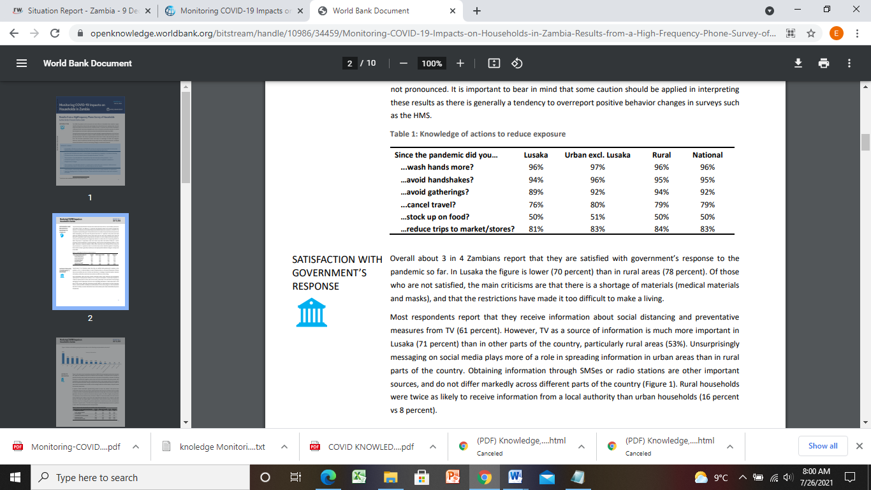
Source: World Band Group; HMS 2020

It is worth mentioning that even if the researcher did not ask about symptoms of COVID 19, the respondents in all the study areas assessed explained on the symptoms of COVID-19; and stated that the symptoms of COVID-19 majorly identified as cough, sneezing and fever and that it is spread of COVID-19 through hand shaking and physical contact with infected persons. And when asked about the source of information, they mentioned that the main sources of information on COVID-19 were radio and local clinics.
In all the three districts the farmers indicated that COVID 19 had impacted negatively on their livelihoods as they had lost relatives and friends but life had become expensive as goods and services including farm inputs and transport costs had gone up making difficult for them to recover.

The farmers reported to have delayed to harvest, as they feared of hiring outside labour that may infect them with COVID 19, some reported to have managed to harvest but feared to move to take to FRA to sell, and this made them to sell cheaply to briefcase farmers who came and offered very low prices. In desperation they would agree in fear of products going to waste if not sold early. Most of them especially Mpongwe farmers reported that even if they hired external labour, they did not have money to pay.

Farmers that were farming vegetables, tomatoes and other perishable produce indicated that their produce were destroyed in the field and particularly the vegetables and those that they managed to take to the market fetched low prices due their reduced quality. Farmers, who kept livestock, reported that inputs and feed have become very expensive, making it difficult to buy and keep livestock healthy. This also affected prices on offered by the buyers.

The findings of the study was similar to the findings of the study done by Action Aid Zambia, (2020), which revealed that most small-scale farmers in Nalolo, Mongu and Chipata depend on selling of these farm produce for their livelihoods. Moreover, the restrictions in their movements as a means to mitigate the spread of COVID19 has negatively affected them because their livelihoods depend largely on trading at various markets. The most notable and sad part of this, is that some of the farm produce which are ready for harvest are horticulture products like tomatoes and vegetables which are perishable in nature and are now going to waste.

Secondly, those who have been going to buy farm produce from the small-scale farmers are taking advantage of the situation by offering farmers low prices for their produce. At this point farmers feel that they do not have a choice but to sell to their current clients even if the requested price is low, for fear that they could not cope with post-harvest loses.
4.1.4. Lessons Learnt by Farmers
4.1.4.1 What must be done to improve food system and also protect women land rights
The findings from the discussion from the farmers’ respondents from the three districts was that hunger, food insecurity and landlessness impacted negatively on women and children in rural areas and hence the need to address the barriers constraining achievement of full potential in the agriculture sector through women participation and empowerment.
On climate change, the farmers are farmers need to adopt agroecological farming practices if they are to overcome climate change based impacts. Farmers have also learnt that they need to promote and preserve their indigenous seeds which they can fall back to after times of drought and floods and which also provide nutrition and health benefits especially in the environment of COVID 19. Additionally, the farmers learnt that agroecological farming practices appear slow to give the desired yield but in the long term they were high yielding and sustainable.
4.2 Findings from Policy Makers and Key Informants
The researcher conducted interviews with the Government Officers that work with farmers in rural areas which included the district Community Development Officers and Agriculture Officers from the Ministry of Agriculture in Lufwanyama, Mpongwe and Luanshya. .
4.2.1 Stakeholder involvement.
4.2.1.1 The District Community Development Officers (DCDOs) and the District Agriculture Officers (DAOs)
The researcher conducted the interview of the DCDOs and DAOs online before the commencement of the interviews and sought their consent on the interviews. They accepted and responded and explained what their offices were doing in enhancing food and nutrition security in their respective districts. They informed that besides distributing farming inputs, they also educated farmers on the mitigation activities against Covid 19 at personal level. They indicated that they had challenges providing extension services to farmers due to the prevailing COVID 19 restrictions bur resulted to limited on phone services. All the officers interviewed reported that the woman and school going children were most affected during COVID 19 due to closure of schools and markets.

4.2.7. Suggestions from the KIIs of the DCDOs and DAOs
4.2.7.1 Recommendations for farmers to respond to food insecurity and future pandemics.
The following were the recommendation that were made to the farmers.
- Farmers should explore new opportunities of crops and farming methods that will be managed in the current climate change challenges and in combating the spread of COVID19.
- They should diversify in their farming style so as to meet the demand and mitigate nutrition problems challenges among children and adults.
- Farmers should form community groups to come up with community projects that will enhance food sovereignty and resilience.

4.2.7.2. Recommendations for government
The following were the recommendation that were made for government.
- The Government through the Ministry of Health should sensitise the farmers and the officers working in rural communities on COVID 19.
- The Government should recognize and support farmer managed seed systems and develop a crop diversification strategy
- Government should review the Farmer Input Support Programme ( FISP) to ensure it meets the needs of smallholder farmers
- Government should facilitate implementation of land administration and women rights to land ownership.
- The government should arrange for the farmers the FRA deport to be near the communities because it is expensive for the farmers to move to offices of the FRA in town.
- The government should regulate the pricing of the farm inputs as they are very expensive for smallholder farmers to afford.
- Government should sensitize rural communities on women land rights and facilitate legal reforms
- Promote nutrition and early childhood education in rural areas

4.2.7.3. Recommendations for CSOs
The following were the recommendation that were made for CSOs.
- They should support the Government in building capacity of smallholder farmers and Government staff involved in agriculture related activities eg extension services.
- Sensitize rural communities on Women Land Rights
- Advocate for rural women legal rights to own, inherit and transfer land.
- Engage with traditional leaders in addressing norms and customs on how women can acquire land
- Conduct nutrition education in rural areas
- Advocate for land governance reforms and joint titling
- Promote farmer managed seed systems
- Advocate against corporate takeover of seed and food systems
- Promote nutrition and early childhood education in rural areas

CHAPTER FIVE: CONCLUSION AND RECOMMENDATION
5.1 Conclusions
Hunger, food insecurity and under-malnutrition, and secure land tenure are global challenges and threaten mostly smallholder farmer households and mainly women and children. On the other hand barriers in women land ownership is one factor perpetuating rural poverty, hunger and malnutrition in rural areas. Besides, COVID-19 pandemic has had radical impact on farmer’s food system and the rights of smallholder farmers in our Zambia. This has had effects on peoples’ livelihoods leading to disruptions across various food chains, thus food systems been impacted negatively. Government’s bias on conventional farming through FISP has had a negative impact on crop diversification which is essential in promoting food and nutrition security among the rural poor. This has adverse effects on their consumption of adequate nutritious and diverse diets that reduce malnutrion among rural households.

5.2 Recommendation
There are various efforts that are being implemented by Government and stakeholders to address the impact of climate, hunger, food security and landlessness and the COVID 19 pandemic on the population. The main challenge with the Government response has been the reduced monetary space that has affected the delivery of Government’s programmes as a result of insufficient and irregular disbursement of funds.
In view of the above, the researcher would like to put up the following:
- The government to come up with development programs of mitigation measures that will food insecurity and minimize the impact of COVID-19 in rural areas. This is a great concern because most of the mitigation programs are centered mostly in urban areas.
- The government to control the prices of essential food and farming inputs so that during this period of the pandemic, smallholder households will not have to strain to buy farm inputs as a result of high prices.
- Government should recognize and promote agroecology as a better option to the high input and expensive corporate farming.
- The government strategize on crop diversification for smallholder farmers
- Government should facilitate joint titling of land to facilitate women land ownership
- Government should develop and implement COVID 19 recovery programme for smallholder farmers.

References
- Actionaid Zambia, (2020). Covid-19 Impact on Small Scale Farmers in Zambia. A case of chipata, mongu and nalolo districts. Retrieved from https://zambia.actionaid.org/opinions/2020/covid-19-impact-small-scale-farmers-zambia on 02/07/2021.
- Reliefweb (2020). COVID-19 Rapid Food Security Vulnerability Impact Assessment Report – Conducted In Lusaka And Kafue Districts . retrieved from eliefweb.int/report/zambia/covid-19-rapid-food-security-vulnerability-impact-assessment-report-conducted-lusaka on 02/07/2021
- Fac ice team (2021). Covid-19 preventative measures disrupt small-scale. Apra blog, fac blog. Retrieved from https://www.future-agricultures.org/blog/covid-19-preventative-measures-disrupt-small-scale-farmer-production-marketing-and-livelihoods-in-zambia on 02/07/2021
- Matenga C and Hichaambwa M (2021). COVID-19 preventative measures disrupt small-scale farmer production, marketing and livelihoods in Zambia retrieved from https://www.future-agricultures.org/blog/covid-19-preventative-measures-disrupt-small-scale-farmer-production-marketing-and-livelihoods-in-zambia/ on 20/07/2021
- FAO of UN (2020). Coronavirus disease 2019 (COVID-19) and family farming. Retrieved from http://www.fao.org/family-farming/detail/en/c/1300574 on 02/07/2021
- Shenggen Fan (2020) The COVID-19 crisis has brought with it many important warnings and lessons. None more so than the fragility of our global food system. Retrieved from https://www.glopan.org/opinion-the-covid-19-crisis-has-brought-with-it-many-important-warnings-and-lessons-none-more-so-than-the-fragility-of-our-global-food-system on 01/07/2021
- https://openknowledge.worldbank.org/bitstream/handle/10986/34459/Monitoring-COVID-19-Impacts-on-Households-in-Zambia-Results-from-a-High-Frequency-Phone-Survey-of-Households.pdf?sequence=1&isAllowed=y on 18/07/2021
- Carreras, M.; Saha, A. and Thompson, J. (2020) Rapid Assessment of the Impact of COVID-19 on Food Systems and Rural Livelihoods in Sub-Saharan Africa. APRA COVID-19 Synthesis Report 2, Brighton: Future Agricultures Consortium. Retrieved from https://www.future-agricultures.org/publications/rapid-assessment-of-the-impact-of-covid-19-on-food-systems-and-rural-livelihoods-in-sub-saharan-africa/ on 14/07/2021
- LaMorte W. W. (2019). Health Belief Model. Retrieved from https://sphweb.bumc.bu.edu/otlt/MPH-Modules/SB/BehavioralChangeTheories/BehavioralChangeTheories2.html on 26/07/2021
- https://www.russellsage.org/research/funding/covid-19-pandemic, on 25/07/2021
- WHO (2020). Impact of COVID-19 on people's livelihoods, their health and our food systems Retrieved from Impact of COVID-19 on people's livelihoods, their health and our food systems

